CSE 455 HOMEWORK 4
COLOR CLUSTERING AND SKIN FINDING
Name: Zhuonan Sun

1. Introduction
Use an algorithm of k-means developed for hw3 to find clusters in normalized r-g space and to classify the skin areas on images containing faces. Then use WEKA to build a model with training data, using Naïve Bayes and Voted Preceptron classifiers. Compare the skin images the model produces with the groundtruth images, and report.
2. Skin Finding
2.1 Method

I decided to use the second method, selecting seeds from image pixels, for my modified kmeans algorithm.
2.2 Classifiers tested and the accuracy that each one obtained (from WEKA)
Naïve Bayes:
TRAINING:
Correctly Classified Instances 110 61.1111 %
Incorrectly Classified Instances 70 38.8889 %
Kappa statistic 0.2176
Mean absolute error 0.4801
Root mean squared error 0.4919
Relative absolute error 96.7846 %
Root relative squared error 98.7794 %
Total Number of Instances 180

=== Detailed Accuracy By Class ===

TP Rate FP Rate Precision Recall F-Measure ROC Area Class
0.633 0.415 0.646 0.633 0.639 0.65 0
0.585 0.367 0.571 0.585 0.578 0.65 1
Weighted Avg. 0.611 0.393 0.612 0.611 0.611 0.65

=== Confusion Matrix ===

a b <-- classified as
62 36 | a = 0
34 48 | b = 1

TESTING:
Correctly Classified Instances 105 58.3333 %
Incorrectly Classified Instances 75 41.6667 %
Kappa statistic 0.1794
Mean absolute error 0.4859
Root mean squared error 0.4955
Relative absolute error 98.5361 %
Root relative squared error 100.0906 %
Total Number of Instances 180

=== Detailed Accuracy By Class ===

TP Rate FP Rate Precision Recall F-Measure ROC Area Class
0.529 0.342 0.679 0.529 0.595 0.605 0
0.658 0.471 0.505 0.658 0.571 0.605 1
Weighted Avg. 0.583 0.397 0.606 0.583 0.585 0.605

=== Confusion Matrix ===

a b <-- classified as
55 49 | a = 0
26 50 | b = 1

Voted Perceptron:
TRAINING:
Correctly Classified Instances 94 52.2222 %
Incorrectly Classified Instances 86 47.7778 %
Kappa statistic -0.0073
Mean absolute error 0.455
Root mean squared error 0.623
Relative absolute error 91.7256 %
Root relative squared error 125.0933 %
Total Number of Instances 180

=== Detailed Accuracy By Class ===

TP Rate FP Rate Precision Recall F-Measure ROC Area Class
0.786 0.793 0.542 0.786 0.642 0.533 0
0.207 0.214 0.447 0.207 0.283 0.533 1
Weighted Avg. 0.522 0.529 0.499 0.522 0.478 0.533

=== Confusion Matrix ===

a b <-- classified as
77 21 | a = 0
65 17 | b = 1

TESTING:
Correctly Classified Instances 93 51.6667 %
Incorrectly Classified Instances 87 48.3333 %
Kappa statistic -0.0806
Mean absolute error 0.4516
Root mean squared error 0.6167
Relative absolute error 91.5771 %
Root relative squared error 124.5632 %
Total Number of Instances 180

=== Detailed Accuracy By Class ===

TP Rate FP Rate Precision Recall F-Measure ROC Area Class
0.808 0.882 0.556 0.808 0.659 0.567 0
0.118 0.192 0.31 0.118 0.171 0.567 1
Weighted Avg. 0.517 0.591 0.452 0.517 0.453 0.567

=== Confusion Matrix ===

a b <-- classified as
84 20 | a = 0
67 9 | b = 1

2.3 Tests and Results (include instruction on how to run program)

You need to try at least 2 classifiers including naïve bayes and report skin-labeled image and accuracy for each required image (face01, face04, face05, face08, face10, face23, face28) . For each image, accuracy is defined as number of correctly classified pixels over total number of pixels after comparing your skin labeled image with ground truth image. You only need to display skin-labeled image worked by naïve bayes, but you should report the accuracy for all classifiers you’ve tried.
Please follow the format below for results report:

- Name: face28
Original Image Skin-Labeled Image
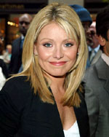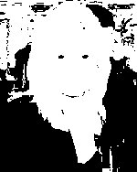
Naïve Bayes Accuracy Other Classifier’s Accuracy
58% 78% (Voted Perceptron)

- Name: face01
Original Image Skin-Labeled Image
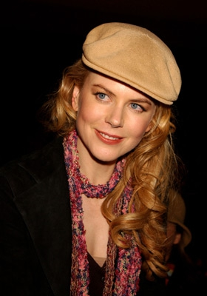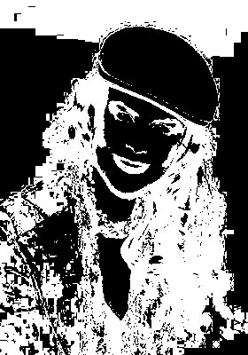
Naïve Bayes Accuracy Other Classifier’s Accuracy
44% 44%

(3) Name: face04
Original Image Skin-Labeled Image
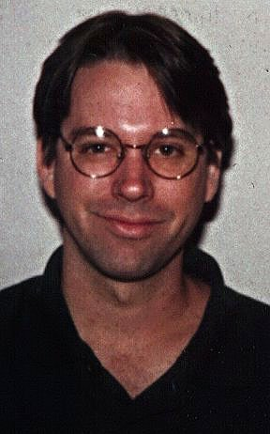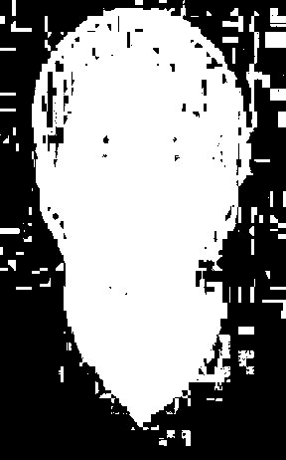
Naïve Bayes Accuracy Other Classifier’s Accuracy
77% 75%
(4) Name: face05
Original Image Skin-Labeled Image
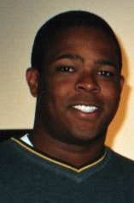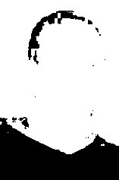
Naïve Bayes Accuracy Other Classifier’s Accuracy
58% 83%

(5) Name: face08
Original Image Skin-Labeled Image
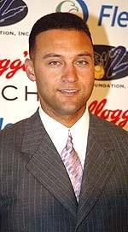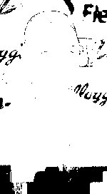
Naïve Bayes Accuracy Other Classifier’s Accuracy
30% 82%

(6) Name: face10
Original Image Skin-Labeled Image
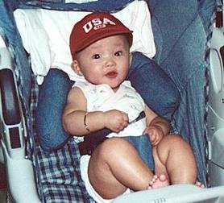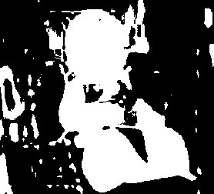
Naïve Bayes Accuracy Other Classifier’s Accuracy
80% 78%
(7) Name: face23
Original Image Skin-Labeled Image
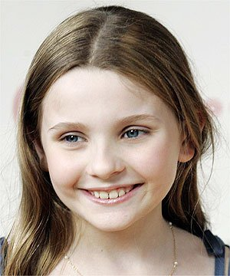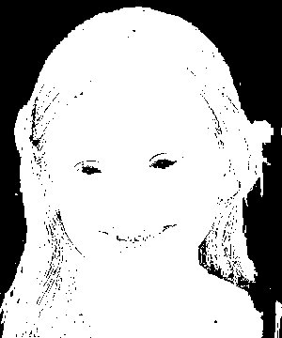

Naïve Bayes Accuracy Other Classifier’s Accuracy
64% 57%

INSTRUCTION:
- ./kmeans.sh, to produce labels, k-means tables, and colors images for reference
- ./arff.sh, which will produces two ARFF files called “training.arff” and “testing.arff” based on the files produced in step 1.
- Open WEKA, load the training.arff, and test the model with training and testing sets, with Naïve Bayes and Voted Perceptron classifiers.
- To produce the prediction image, first we need to get the prediction result. Copy the content of “The Prediction Test Splits” in the report of any classifier, paste it on training_result.txt or testing_result.txt, depending on which report you take the data from.
- Replace “+”, “*”, and “:” with “ ” (single space), in order to parse the data easier.
- After training_result.txt and testing_result.txt both being fill with the proper data, ./prediction.sh to produce 30 prediction images.
- ./accuracy.sh to get the accuracies for 7 required images. The result will be in “output.txt.” The content of the file will not be cleared every time you run the command, unless you manually erased them.

DISCUSSION:
Cluster accuracy, from WEKA, showed a poor result of the model. However, the pixels accuracy shows that cluster accuracy does not affect the production of prediction image that badly, since pixel accuracy are relatively high, generally over 60% for Naïve Bayes, and about 80% for Voted Perceptron. The statistics also tell that Voted Perceptron does better than Naïve Bayes on skin recognizing.

Some results are bad for both classifiers, such as face01 and 23. I think it’s because my k-means algorithm, which randomly find seeds from image pixels did not meet their best cases for all 30 images. I ran everything uniformly, with a uniform K = 12. So some images might had bad labels (cloth /hair /environment have the same color with face, etc.), which undermined the training, causing the model not smart enough. This can be fixed by running separately on the images that have bad labels until the labels are reasonably located. However this homework was quite time-consuming, and I did not have enough time to get it fixed.

